EEZ project – Extension definitions

The specific instrument model/type within a larger family of instruments (i.e. Build configurations as described under Settings section) is defined under Extension definitions tab. A newly created project does not contain any instrument definition. Use Add option to create as many different instruments as needed (Fig. 1.).

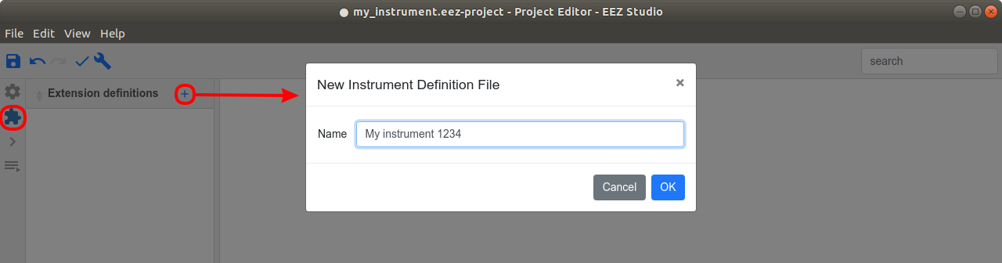Fig. 1: Add new instrument definition
A newly added instrument definition will produce few error caused by automated checking mechanism (Fig. 2). Reported errors are pointing to the mandatory fields.

The Extension definitions hve the following parameters (mandatory parameters are marked bold) that follow the Instrument definition file (IDF) structure of Keysight's Offline Command Expert command set:
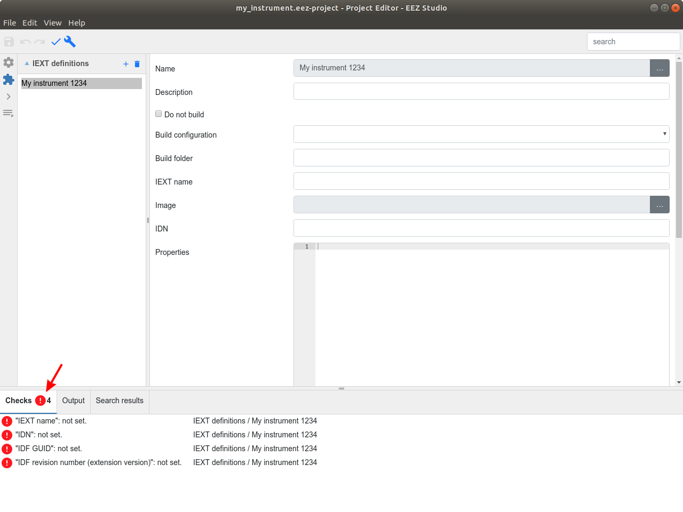Fig. 2: Empty instrument definition errors

Parameter | Explanation
Name | Instrument name, has to be unique.
Description | Instrument specific description that will be displayed together with Build Definition description as specified in Settings section.
Do not build | Exclude instrument from collection that will be made during the IEXT building process.
Build configuration | List of all build configuration defined in Settings section.
Build folder | Destination folder when IEXT will be build. Default value is empty for using the same folder as the project file.
IEXT name | Target IEXT .zip file name, for example rigol_mso1104zs is used to create rigol_mso1104zs_xxx.zip where xxx is defined by IDF revision number.
Image | Instrument picture that will be displayed in ESW for easier instrument recognition. If not specified, a default “image no selected” thumbnail will be used. Recommended folder for instrument images is doc/images.
IDN | Identification string that contains manufacturer name, followed by model name that is expected at the beginning of the received result from *IDN? Query (e.g. RIGOL TECHNOLOGIES,DS1054Z).
Properties | Instrument specific ESW properties, if specified will override Properties defined in the Build configurations described in Settings section (e.g. instrument specific color scheme).
IDF name | Instrument name, used also as instrument display name.
IDF short name | Instrument short name, not used by EEZ Studio, but it is stored into IDF file (part of the IEXT .zip package).
IDF firmware version | Instrument firmware version.
IDF GUID | Instrument's GUID (Globally Unique Identifier). A new value will be generated each time when accompanied “+” option is selected.
IDF revision number (extension version) | Revision number that is used as IEXT .zip file suffix and to distinguish between more IEXT's revision of the same instrument.
IDF description | Instrument information that will be displayed next to instrument name in ESW IEXT list (e.g. 70 MHz Digital Oscilloscope for Rigol DS1074Z model).
IDF supported models | List of supported instrument models, not used by EEZ Studio, but it is stored into IDF file (part of the IEXT .zip package).
IDF revision comments | Additional revision information (e.g. what's new, etc.).
IDF author | Information about IEXT author (e.g. Envox for EEZ instruments).
SDL friendly name | Instrument friendly name, not used by EEZ Studio, but it is stored into SDL file (part of the IEXT .zip package).

